Tanja Poppelreuter
Neue Sachlichkeit (New Objectivity)
The term Neue Sachlichkeit was coined by Gustav Hartlaub with his exhibition: “Neue Sachlichkeit. Deutsche Malerei seit dem Expressionismus” (New Objectivity. German Painting Since Expressionism) at the Kunsthalle Mannheim in 1925 and is now used to describe a movement during the politically, socially, and economically unstable years of the Weimar Republic in Germany (1919-1933) that includes painting, photography, design, and architecture (Rewald, 2006).
In architecture the term mainly relates to Neues Bauen (New Building) and avant-garde currents of rationalist and functionalist modernism that existed alongside conservative counterparts and expressionism. Among its contributors in Germany were Walter Gropius, Otto Haesler, Ludwig Hilberseimer, Ernst May, Hannes Meyer, Ludwig Mies van der Rohe, and Martin Wagner. Architecture and design was created in order to fulfill objective functions and not along the lines of personal taste, preexisting historical, national, or regional styles. The Sache – the object, subject matter – was scrutinized in order to fulfill its function and serve its user best as possible. The way in which this was approached was sachlich – objectively and factually – without emotional attachment to ways in which the object was designed or used previously. Neue Sachlichkeit therefore was an approach to design pursuing, but not always achieving, practicality, suitability, and objectivity by setting aside all matters considered by its practitioners as irrelevant (Schwartz, 1998 and Schmalenbach, 1940).
Architecture of the Neue Sachlichkeit is associated with buildings free of ornament, representational features, consisting of simple geometry, and shaped by inherent functions. Its contributors drew on theories already apparent before World War I, such as on Adolf Loos’ 1910 essay ‘Ornament und Verbrechen’ (‘Ornament and Crime’). German contributors related to contemporary international avant-garde movements such as De Stijl, Russian Constructivism, or Futurism and to practitioners such as Frank Lloyd Wright and Le Corbusier. Architectural groups (‘Der Ring’) and architectural magazines (‘Das Neue Frankfurt’, ‘Die Form’) also were founded in support of this new movement (Curtis, 1996, Lampugnani, 1994).
To convince the public about the efficacy of the design critic Adolf Behne, for example, compared the interiors of the 19th-century and of the Jugendstil (Art Nouveau) to the interior of the Haus am Horn [Fig. 1]. A clear, uncluttered interior was pursued because it was thought to be beneficial for health and wellbeing. The Haus am Horn, as one of the earliest examples of Neues Bauen, was built in 1923 by the Bauhaus in Weimar [Fig. 2]. It was planned as a prototype that would fit the requirements of the majority of home-seeking working-class tenants. While it failed to achieve this goal in that it was considered too large and expensive for the targeted clientele, its objective related to the new social and ethical attitude to design in that architectural innovations were sought to increase living standards of the working class.
This attitude to design arose in relation to the social and political context of the time. A severe housing shortage, caused by 19th-century housing politics and the First World War, made the development of mass housing necessary and with it questions arose as to how to revolutionize the building process to save time and costs, which new materials could be used and developed, how much space could be allocated per person, and how to envision the lifestyle of modern man. In the second half of the 1920s a number of works then could be realized and in response to such questions.
In cities, that were most affected by the housing shortage, such as Berlin [Fig. 3-4 + video] and Frankfurt, modern architects Martin Wagner (Berlin) and Ernst May (Frankfurt) were appointed to build settlements for the ‘Existenzminumim’ on a great scale. In May’s team architects and designers were involved such as Martin Elsaesser, Adolf Meyer, Ferdinand Kramer, Leberecht Migge, Eugen Kaufmann, Margarete (Grete) Schütte-Lihotzky, Walter Gropius, and Mart Stam. 15,000 apartments in settlements as well as schools, churches, and parks were built between 1925 and 1930 in Frankfurt alone [Fig. 5-7]. To achieve this, May developed ‘Typengrundrisse’ [Fig. 5] for different size families which would decrease building times and enable standardization. These living spaces were reduced to a minimum but at the same time it was ensured that each apartment would receive sunlight and fresh air. Settlements were planned so that tenants had easy access to green spaces, and public transport. Efforts to optimally shape each room according to its functions resulted in the prediction and measurement of movement inside the rooms. Grete Schütte-Lihotzky’s Frankfurt Kitchen [video] was developed to relieve the housewife by saving time and energy for cooking and cleaning.
Walter Gropius was also concerned with the standardization and prefabrication of building components, construction methods, and house types as in the settlements in Dessau Törten (1926-28), Karlsruhe Dammerstock (with Otto Haesler) (1928-29) and in his contribution to Berlin Siemensstadt (1929-30) [Fig. 8-10 + video].
Hannes Meyer, second director of the Bauhaus and one of the left wing representatives of the Neues Bauen, understood design as a social act. His 1928 manifesto ‘bauen’ declared the house to be a biological apparatus for spiritual and physical requirements, and that building was the organization of social, technical, economic and psychological needs. His position towards objective and functional design becomes also apparent in his approach to teaching, in that he encouraged students to study the ‘life process’ of the user and to relate their design to specified requirements (Meyer-Bergner, 1980).
To provide an international platform on which to test and compare innovations the Deutsche Werkbund organized exhibitions in Stuttgart-Weißenhof (1927), organized by Ludwig Mies van der Rohe, [Fig. 11 + video], Breslau (1929), and Vienna [Fig. 12] (1932) at which architects were invited to showcase their use of novel materials and building methods as well as their vision of life in their dwellings.
The Great Depression of 1929 caused American banks to recall their loans to Germany and during the ensuing worldwide economic crisis the building-boom of the latter years ceased. Adolf Hitler’s seizure of power and establishment of a dictatorship in 1933 then put an end to the Neues Bauen in Germany.
Even though manifestos and publications demanded a radical change in the building process towards developing standardized building blocks or “housing machines”, the modern buildings were mostly still erected with traditional methods. Functionality or objectivity in design was at times confused with simplicity in form, and theoretical claims were not always achieved in practical application in that, for example, flat roofs could not be constructed effectively, nor were they always weatherproof. Theoretical utterances about the nature of Neues Bauen and Neue Sachlichkeit were disparate and complex and the movement was not as unified as historiography and proponents of this movement suggested.

Word Count: 1100

References and further readings:
Banham, P. R. (1960) Theory and Design in the First Machine Age, Architectural Press: London.
Behne, A. (1926) Der moderne Zweckbau, Gebr. Berlin: Mann Verlag, (Reprint 1998).
Benton, C. ed. (1975) Documents. A collection of Source Material on the Modern Movement, Milton Keynes: The Open University Press.
Benton, C. and T. Benton eds. (1975) A Source Book on the History of Architecture and Design 1890-1939 Milton Keynes: The Open University Press.
Curtis, W. J. R. [1996], Modern Architecture Since 1900, Oxford: Phaidon Press.
De Zurko, E. R. (1957) Origins of Functionalist Theory (Columbia University Press: New York.
Lampugnani, V. M., Schneider, R. (1994) Moderne Architektur in Deutschland 1900 bis 1950: Expressionismus und Neue Sachlichkeit, Ostfildern: Hatje Cantz.
Lane, B. M. (1968) Architecture and Politics in Germany, 1918–45, Harvard University Press : Cambridge, MA.
Meyer-Bergner, L. ed. (1980) Hannes Meyer. Bauen und Gesellschaft: Schriften, Briefe, Projekte, Dresden: VEB Verlag der Kunst.
Rewald, S. et al. (2006) Glitter and Doom. German Portraits from the 1920s, New Haven and London: The Metropolitan Museum of Art, Yale University Press.
Schmalenbach, F. (1940) ‘The Term Neue Sachlichkeit’, The Art Bulletin 22 (3): 161-165.
Schwartz, F. J. (1998) ‘Form Follows Fetish: Adolf Behne and the Problem of ‘Sachlichkeit’’ Oxford Art Journal 21 (2): 47-77.
Sharp, D. (2002) Twentieth-Century Architecture. A visual History, London: Images Publishing.
Taut, B. (1926) Die Neue Wohnung. Die Frau als Schöpferin, Leipzig: Klinkhardt & Biermann.

Paratextual Material:
Video: Walter Gropius, Siedlung Dessau Törten (In German)
http://www.youtube.com/watch?v=pv7UczYjyKs (1:52)
Video: Die Zwanziger Jahre: Elektrizität, Bauhaus, Frankfurter Küche (In German)
http://www.youtube.com/watch?v=CXtvrLcvWcg (7:16)
Video: Grete Schütte-Lihotzky’s Frankfurt Kitchen
http://www.youtube.com/watch?v=41pyty0-lgs (7:36)
Video: Berlin Modernism Housing Estates – UNESCO World Heritage Site
http://www.youtube.com/watch?v=uoDdIaXW8Hw (1:54)
Video: Weissenhofsiedlung Stuttgart – Ein Rundgang
http://www.youtube.com/watch?v=WU0zJIYf5xI (3:08)

Website: das neue frankfurt eine fotografische sammlung von matthias matzak
http://www.neues-frankfurt.de/
Website: Ernst May und das Neue Frankfurt
http://www.ernst-may-museum.de/maybiografie/
Website: Bauhaus
http://bauhaus-online.de/en
Website: ‘WERKBUNDSIEDLUNG VIENNA 1932 - A MODEL FOR NEW LIVING’ Wien Museum. http://www.wienmuseum.at/en/exhibitions/detail/ausstellung/werkbundsiedlung-wien-1932-ein-manifest-des-neuen-wohnens.html
Collection of Documents
German History in Documents and Images. “Documents - Architecture and Urban Life”
http://germanhistorydocs.ghi-dc.org/sub_doclist.cfm?sub_id=343&section_id=12

Images:

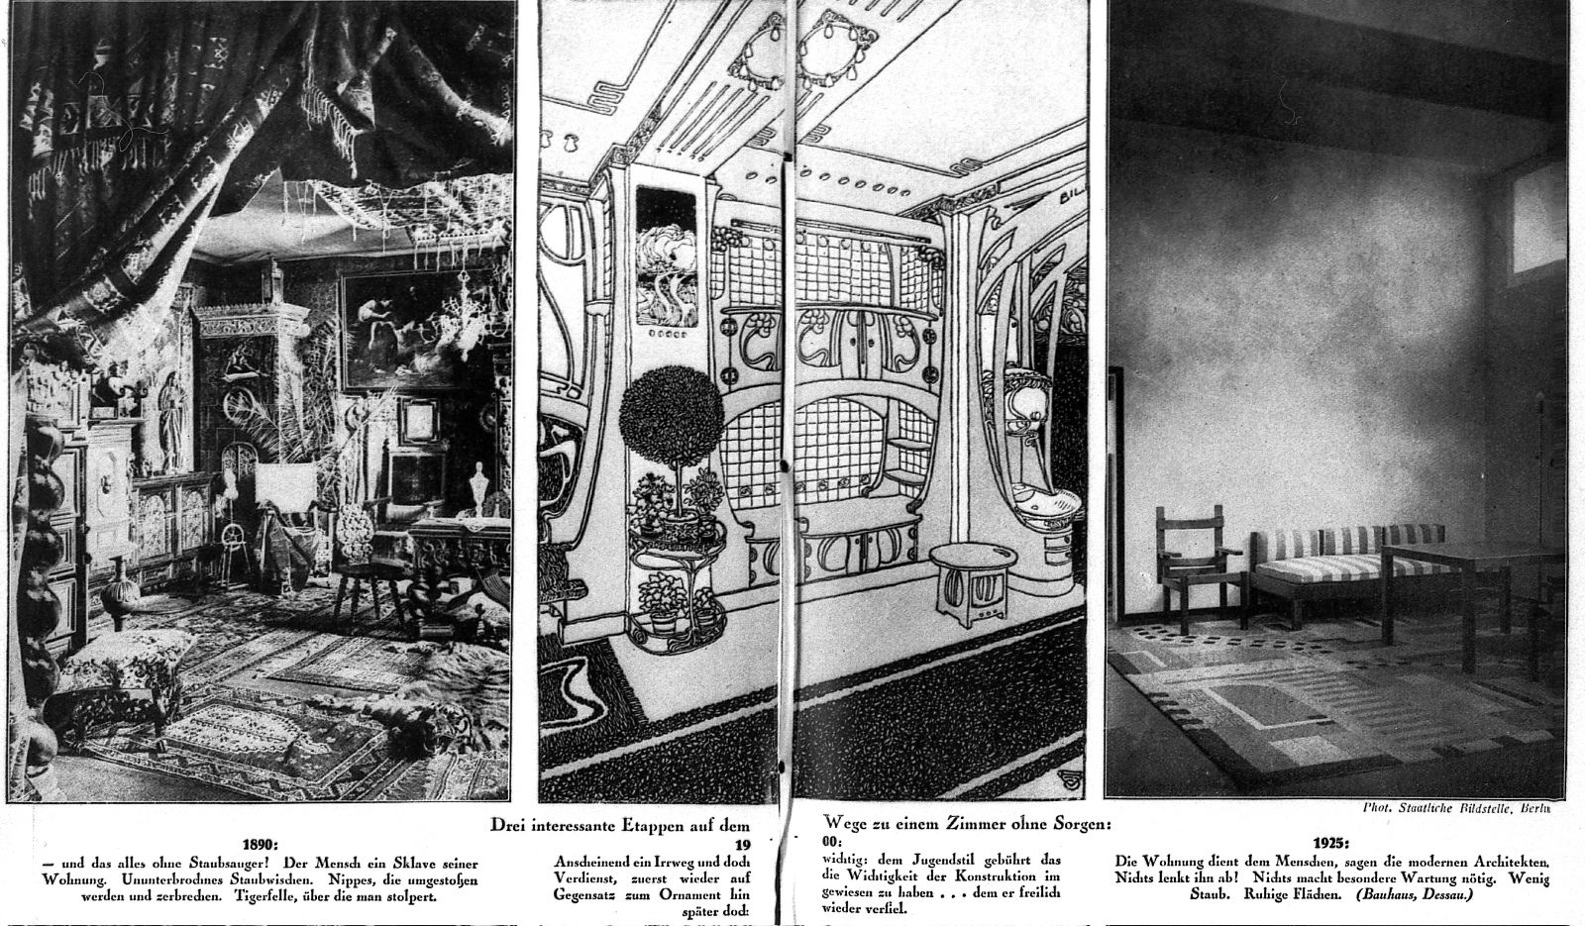
Fig. 1: Illustration ‘Drei interessante Etappen auf dem Wege zu einem Zimmer ohne Sorgen, 1926 in: Adolf Behne, ‘Das Zimmer ohne Sorgen. Wie unsere Kinder wohnen werden’ UHU. Das neue Monats-Magazin, vol. 3 (1926), no. 1, pp. 26-27.
Image rights: Landesdenkmalamt Brandenburg

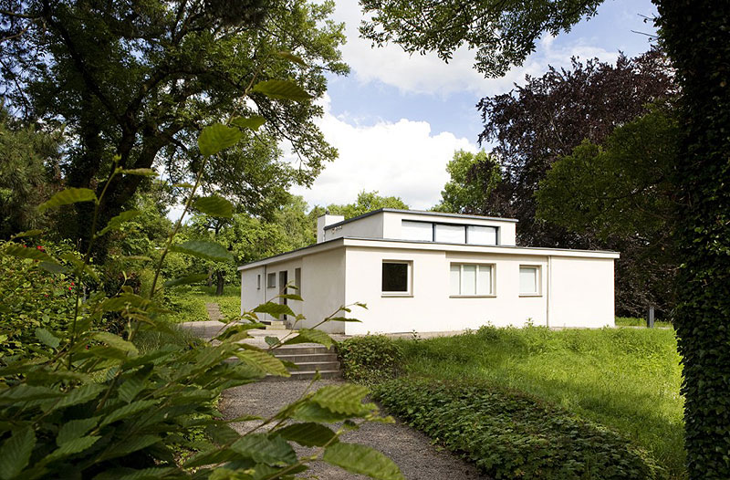
Fig. 2: Georg Muche, Haus am Horn, Weimar, 1923
http://www.weimar.de/nl/tourismus/bezienswaardigheden/unesco-werelderfgoed/bauhaus-sites/haus-am-horn/

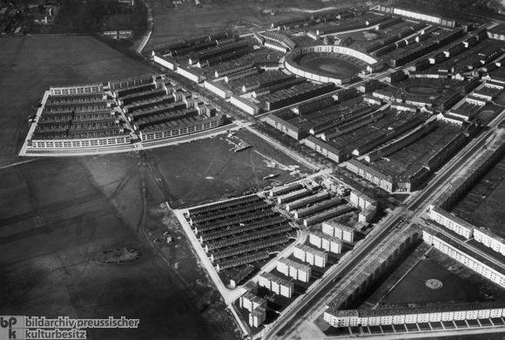
Fig. 3: Bruno Taut, Horseshoe Housing Estate in Berlin-Britz, 1925-30
© Bildarchiv Preußischer Kulturbesitz

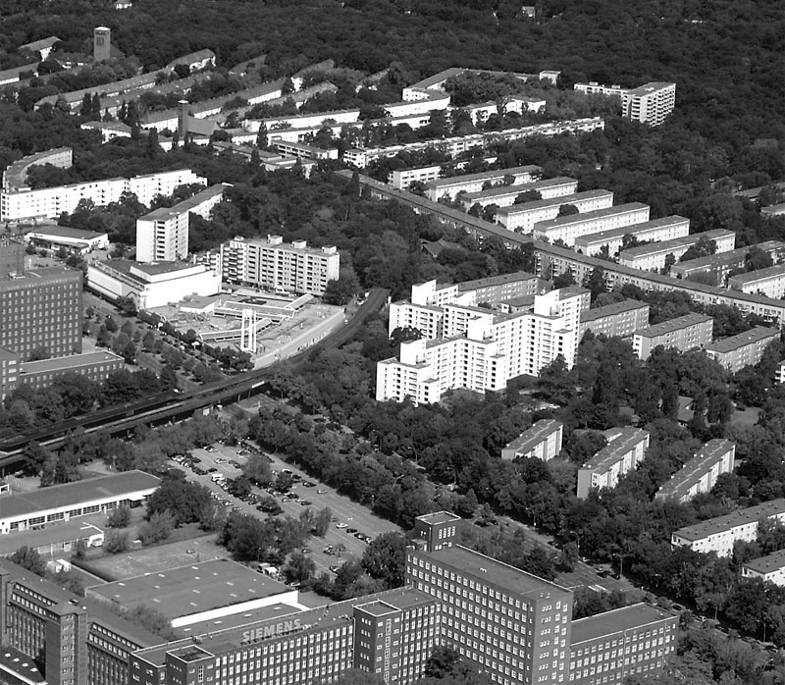
Fig. 4: Martin Wagner (General Management) Berlin-Siemensstadt, 1929-30, aerial view.
http://www.stadtentwicklung.berlin.de/denkmal/denkmale_in_berlin/en/weltkulturerbe/siedlungen/siemensstadt.shtml

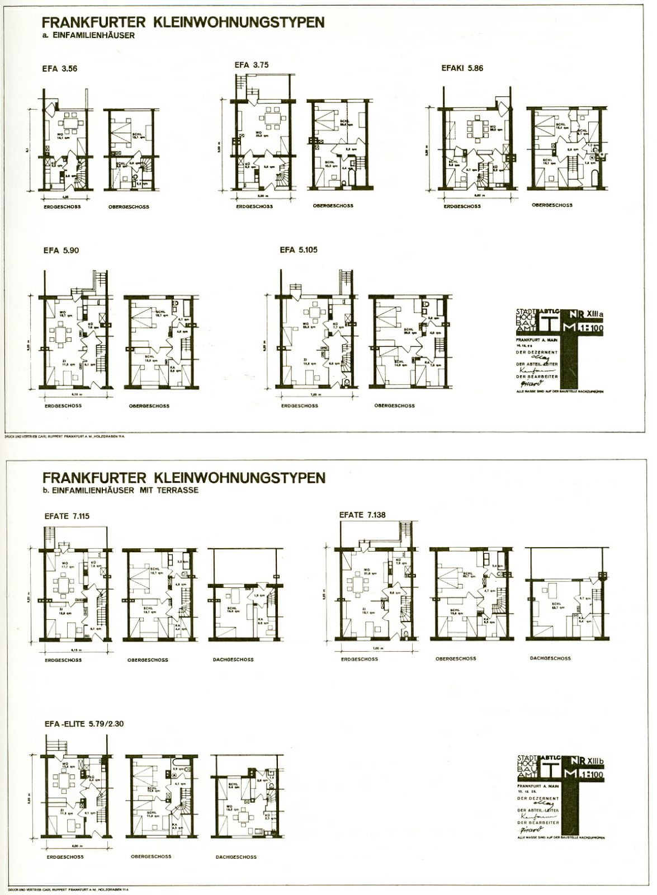
Fig. 5: Ernst May, Frankfurter Kleinstwohnungstypen, 1929
Image Rights: Institute für Stadtgeschichte, Frankfurt am Main

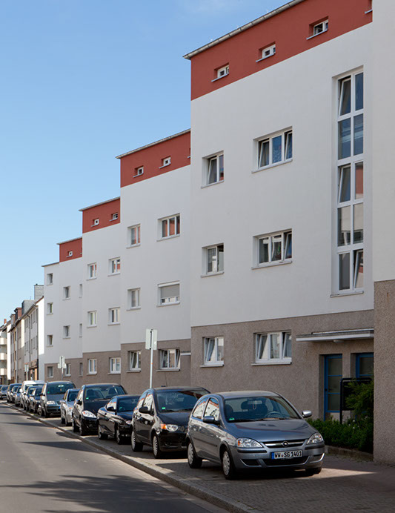
Fig. 6: Ernst May, Herbert Boehm, C. H. Rudloff, Siedlung Bruchfeldstrasse, Frankfurt am Main, 1926-1927
© Matthias Matzak / VG Bildkunst

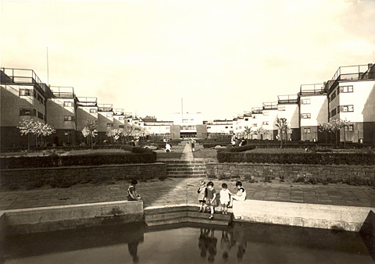
Fig. 7: Ernst May, Herbert Boehm, C. H. Rudloff, Siedlung Bruchfeldstrasse, Frankfurt am Main, 1926-1927
© Deutsches Kunstarchiv, Nürnberg

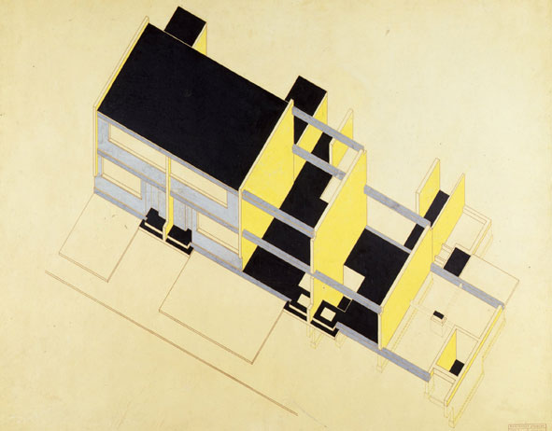
Fig. 8: Walter Gropius, Törten Housing Estate, Dessau. 1926–28, Isometric construction scheme. 1926–28,
Harvard Art Museum, Busch-Reisinger Museum. Gift of Walter Gropius; Photo: Rick Stafford
© President and Fellows of Harvard College, © 2009 Artists Rights Society (ARS), New York / VG Bild-Kunst, Bonn

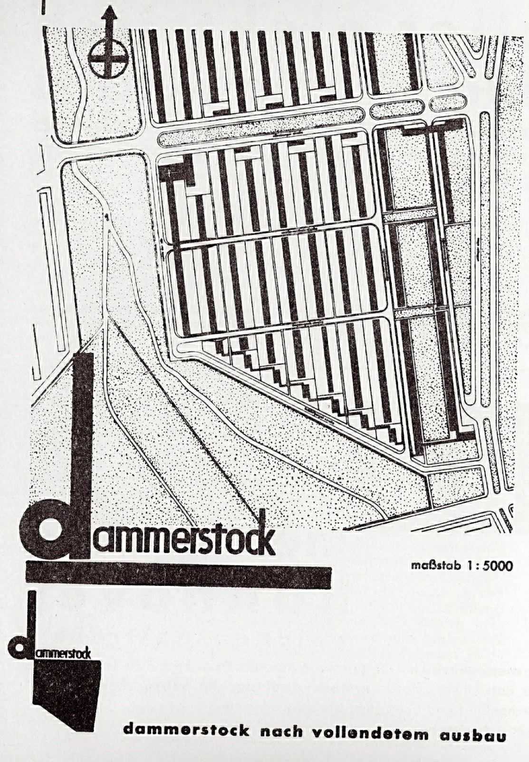
Fig. 9: Walter Gropius, Otto Haesler, Karlsruhe Dammerstock, 1928-29, site plan
http://images.lib.ncsu.edu/des/Size1/NCSULIB-1-NA/1307/104742.jpg?userid=1&username=admin&resolution=1&servertype=JVA&cid=1&iid=NCSULIB&vcid=NA&usergroup=Design_Library-1-Admin&profileid=1

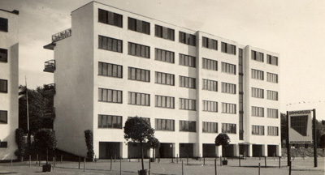
Fig. 10: Walter Gropius, Otto Haesler, Karlsruhe Dammerstock, 1928-29, http://www.karlsruhe.de/b1/stadtgeschichte/staendehaus/dammerstock.de
StadtAK 8/PBS oXIVe 468

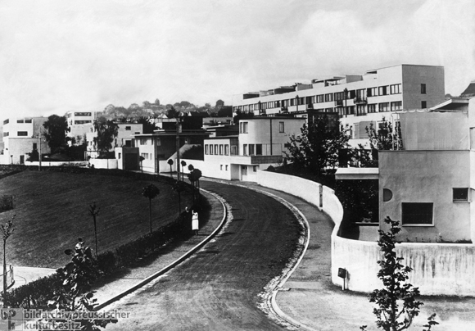
Fig. 11: Deutscher Werkbund, Weissenhof Housing Settlement, Stuttgart 1927
© Bildarchiv Preußischer Kulturbesitz

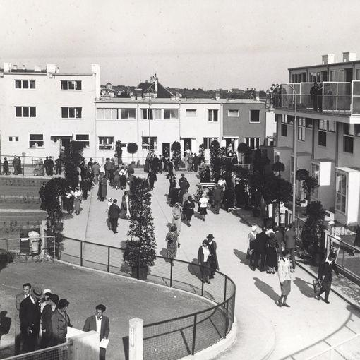
Fig. 12: Opening of the Werkbund estate, Vienna 1932
Albert Hilscher © ÖNB, Bildarchiv und Grafiksammlung

